- The home page should be simple and similar to the current website.

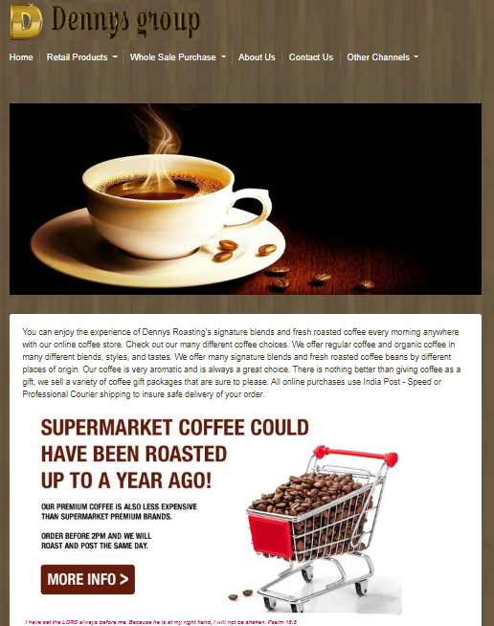

A slider with simple content block as in the figure is only required.

- By default the product page is shown as a list. Please see image below:
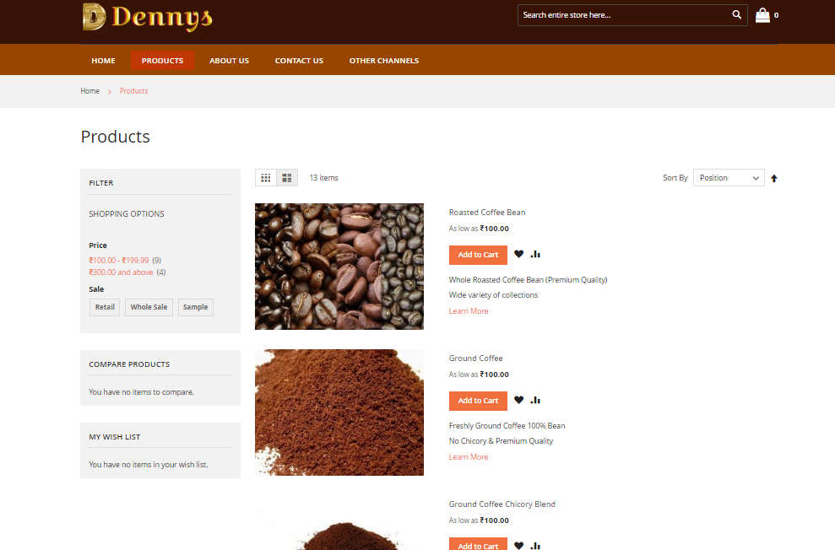
- Show a category filter at the top product list as shown below:
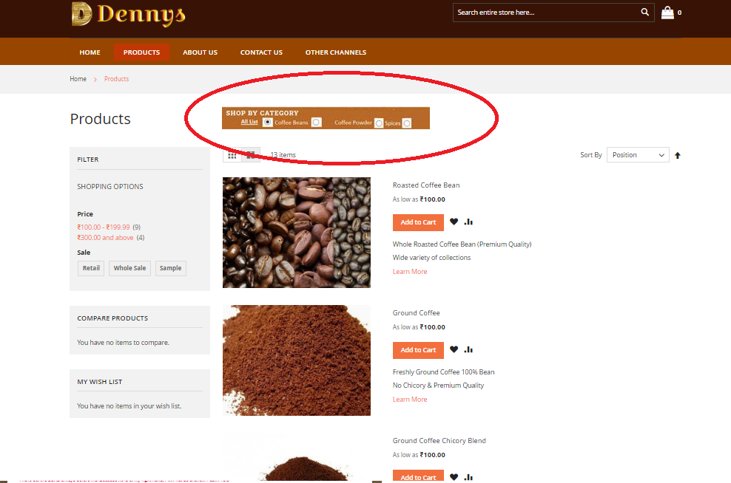
- Category filter is required in sidebar as shown below:
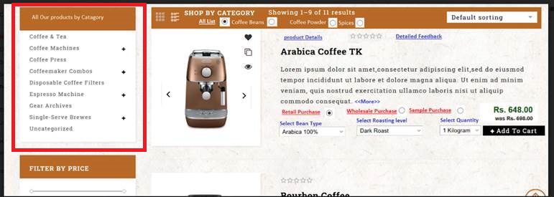

- Product quantity list must be either dropdown or a (plus or minus)
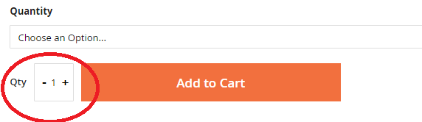

- Instead of loading the image on the new page, use the magnifier to see the full size image.
- Add comment box in checkout page.
- For Whole sale purchases, GSTIN (A text box to enter GSTIN)is required in Checkout page.
- Showing drop downs and check out button in the listing of products itself(the listing of point 2 image )

